Rural Detention
Table of contents

Census API key has been set for this session.

1. RUCA Codes
Code | Classification description
1 | Metropolitan core: primary flow is within an urban area of 50,000 or more people (metro UA)
2 | Metropolitan high commuting: primary flow is 30 percent or more to a metro UA
3 | Metropolitan low commuting: primary flow is 10 percent to 30 percent to a metro UA
4 | Micropolitan core: primary flow is within an urban area of 10,000 to 49,999 people (micro UA)
5 | Micropolitan high commuting: primary flow is 30 percent or more to a micro UA
6 | Micropolitan low commuting: primary flow is 10 percent to 30 percent to a micro UA
7 | Small town core: primary flow is within an urban area of 9,999 or fewer people (small town UA)
8 | Small town high commuting: primary flow is 30 percent or more to a small town UA
9 | Small town low commuting: primary flow is 10 percent to 30 percent to a small town UA
10 | Rural area: primary flow is to a tract outside an UA
99 | Not coded: census tract is entirely in coastal or inland water bodies, with zero population and zero land area
See the RUCA Codes documentation for detailed info on data and methods used for creating RUCA Codes.
Total # of census tracts: 85528
# of continental census tracts: 83776
 | TractFIPS | TractName | CountyFIPS | CountyName | StateFIPS | StateName | RUCA
0 | 01001020100 | Census Tract 201 | 01001 | Autauga County | 01 | Alabama | 1
1 | 01001020200 | Census Tract 202 | 01001 | Autauga County | 01 | Alabama | 1
2 | 01001020300 | Census Tract 203 | 01001 | Autauga County | 01 | Alabama | 1
3 | 01001020400 | Census Tract 204 | 01001 | Autauga County | 01 | Alabama | 1
4 | 01001020501 | Census Tract 205.01 | 01001 | Autauga County | 01 | Alabama | 1

 | Count | Proportion
RUCA
1 | 57544 | 68.69
2 | 8481 | 10.12
3 | 1149 | 1.37
4 | 4630 | 5.53
5 | 2224 | 2.65
6 | 693 | 0.83
7 | 1475 | 1.76
8 | 607 | 0.72
9 | 336 | 0.40
10 | 6343 | 7.57
99 | 294 | 0.35

2. ACS Data

2.1 Cost Burden
Collects variables for housing cost burden (renters and owners spending 30% or more of household income on housing) to measure overall cost burden.
Loaded cached variables for 2024 acs acs5
Loaded cached variables for 2024 acs acs5
 | name | label | concept | predicateType | group | limit | table
0 | B25070_001E | : | Gross Rent as a Percentage of Household Income... | int | B25070 | 0 | B25070
6 | B25070_007E | :30.0 to 34.9 percent | Gross Rent as a Percentage of Household Income... | int | B25070 | 0 | B25070
7 | B25070_008E | :35.0 to 39.9 percent | Gross Rent as a Percentage of Household Income... | int | B25070 | 0 | B25070
8 | B25070_009E | :40.0 to 49.9 percent | Gross Rent as a Percentage of Household Income... | int | B25070 | 0 | B25070
9 | B25070_010E | :50.0 percent or more | Gross Rent as a Percentage of Household Income... | int | B25070 | 0 | B25070
0 | B25091_001E | : | Mortgage Status by Selected Monthly Owner Cost... | int | B25091 | 0 | B25091
7 | B25091_008E | :Housing units with a mortgage:30.0 to 34.9 pe... | Mortgage Status by Selected Monthly Owner Cost... | int | B25091 | 0 | B25091
8 | B25091_009E | :Housing units with a mortgage:35.0 to 39.9 pe... | Mortgage Status by Selected Monthly Owner Cost... | int | B25091 | 0 | B25091
9 | B25091_010E | :Housing units with a mortgage:40.0 to 49.9 pe... | Mortgage Status by Selected Monthly Owner Cost... | int | B25091 | 0 | B25091
10 | B25091_011E | :Housing units with a mortgage:50.0 percent or... | Mortgage Status by Selected Monthly Owner Cost... | int | B25091 | 0 | B25091
18 | B25091_019E | :Housing units without a mortgage:30.0 to 34.9... | Mortgage Status by Selected Monthly Owner Cost... | int | B25091 | 0 | B25091
19 | B25091_020E | :Housing units without a mortgage:35.0 to 39.9... | Mortgage Status by Selected Monthly Owner Cost... | int | B25091 | 0 | B25091
20 | B25091_021E | :Housing units without a mortgage:40.0 to 49.9... | Mortgage Status by Selected Monthly Owner Cost... | int | B25091 | 0 | B25091
21 | B25091_022E | :Housing units without a mortgage:50.0 percent... | Mortgage Status by Selected Monthly Owner Cost... | int | B25091 | 0 | B25091

Getting data from the 2020-2024 5-year ACS
 | GEOID | CostBurden
0 | 01001020100 | 0.168478
1 | 01001020200 | 0.163851
2 | 01001020300 | 0.235628
3 | 01001020400 | 0.142857
4 | 01001020501 | 0.189303

2.2 Poverty Rate
Calculates poverty rate based on the number of people with income below the poverty level in 12 months and divides it by the population.
Loaded cached variables for 2024 acs acs5
 | name | label | concept | predicateType | group | limit | table
0 | B17001_001E | : | Poverty Status in the Past 12 Months by Sex by... | int | B17001 | 0 | B17001
1 | B17001_002E | :Income in the past 12 months below poverty le... | Poverty Status in the Past 12 Months by Sex by... | int | B17001 | 0 | B17001

Getting data from the 2020-2024 5-year ACS
 | GEOID | PovertyRate
0 | 01001020100 | 0.174060
1 | 01001020200 | 0.095051
2 | 01001020300 | 0.071387
3 | 01001020400 | 0.153495
4 | 01001020501 | 0.035104

2.3 Housing Quality
Collects variables for substandard plumbing and kitchen facilities to measure overall housing quality.
Loaded cached variables for 2024 acs acs5
Loaded cached variables for 2024 acs acs5
 | name | label | concept | predicateType | group | limit | table
0 | B25047_001E | : | Plumbing Facilities for All Housing Units | int | B25047 | 0 | B25047
2 | B25047_003E | :Lacking complete plumbing facilities | Plumbing Facilities for All Housing Units | int | B25047 | 0 | B25047
0 | B25051_001E | : | Kitchen Facilities for All Housing Units | int | B25051 | 0 | B25051
2 | B25051_003E | :Lacking complete kitchen facilities | Kitchen Facilities for All Housing Units | int | B25051 | 0 | B25051

Getting data from the 2020-2024 5-year ACS
 | GEOID | HousingQuality
0 | 01001020100 | 0.007916
1 | 01001020200 | 0.100287
2 | 01001020300 | 0.092125
3 | 01001020400 | 0.008419
4 | 01001020501 | 0.000000

2.4 Education
Calculates percentage of the population that does not hold a high school diploma
Loaded cached variables for 2024 acs acs5
 | name | label | concept | predicateType | group | limit | table
0 | B15003_001E | : | Educational Attainment for the Population 25 Y... | int | B15003 | 0 | B15003
1 | B15003_002E | :No schooling completed | Educational Attainment for the Population 25 Y... | int | B15003 | 0 | B15003
2 | B15003_003E | :Nursery school | Educational Attainment for the Population 25 Y... | int | B15003 | 0 | B15003
3 | B15003_004E | :Kindergarten | Educational Attainment for the Population 25 Y... | int | B15003 | 0 | B15003
4 | B15003_005E | :1st grade | Educational Attainment for the Population 25 Y... | int | B15003 | 0 | B15003
5 | B15003_006E | :2nd grade | Educational Attainment for the Population 25 Y... | int | B15003 | 0 | B15003
6 | B15003_007E | :3rd grade | Educational Attainment for the Population 25 Y... | int | B15003 | 0 | B15003
7 | B15003_008E | :4th grade | Educational Attainment for the Population 25 Y... | int | B15003 | 0 | B15003
8 | B15003_009E | :5th grade | Educational Attainment for the Population 25 Y... | int | B15003 | 0 | B15003
9 | B15003_010E | :6th grade | Educational Attainment for the Population 25 Y... | int | B15003 | 0 | B15003
10 | B15003_011E | :7th grade | Educational Attainment for the Population 25 Y... | int | B15003 | 0 | B15003
11 | B15003_012E | :8th grade | Educational Attainment for the Population 25 Y... | int | B15003 | 0 | B15003
12 | B15003_013E | :9th grade | Educational Attainment for the Population 25 Y... | int | B15003 | 0 | B15003
13 | B15003_014E | :10th grade | Educational Attainment for the Population 25 Y... | int | B15003 | 0 | B15003
14 | B15003_015E | :11th grade | Educational Attainment for the Population 25 Y... | int | B15003 | 0 | B15003
15 | B15003_016E | :12th grade, no diploma | Educational Attainment for the Population 25 Y... | int | B15003 | 0 | B15003

Getting data from the 2020-2024 5-year ACS
 | GEOID | LessThanHS
0 | 01001020100 | 0.094197
1 | 01001020200 | 0.097473
2 | 01001020300 | 0.130983
3 | 01001020400 | 0.053578
4 | 01001020501 | 0.031766

2.5 Demographics
Loaded cached variables for 2024 acs acs5
 | name | label | concept | predicateType | group | limit | table
0 | B03002_001E | : | Hispanic or Latino Origin by Race | int | B03002 | 0 | B03002
2 | B03002_003E | :Not Hispanic or Latino:White alone | Hispanic or Latino Origin by Race | int | B03002 | 0 | B03002

Getting data from the 2020-2024 5-year ACS
 | GEOID | PercentMinority
0 | 01001020100 | 0.334643
1 | 01001020200 | 0.676971
2 | 01001020300 | 0.358540
3 | 01001020400 | 0.119048
4 | 01001020501 | 0.215122

2.6 Household Vars
 | GEOID | Gini
0 | 01001020100 | 0.4238
1 | 01001020200 | 0.4100
2 | 01001020300 | 0.3519
3 | 01001020400 | 0.5880
4 | 01001020501 | 0.3954

3. Data Analysis
Merge all individual ACS socioeconomic indicators and combines them with the cleaned RUCA dataset by Census Tract GEOID.
Total ACS tracts merged: 83763
Final tract count: 82879
 | TractFIPS | TractName | CountyFIPS | CountyName | StateFIPS | StateName | RUCA | GEOID | PovertyRate | CostBurden | HousingQuality | LessThanHS | PercentMinority | Gini
0 | 01001020100 | Census Tract 201 | 01001 | Autauga County | 01 | Alabama | 1 | 01001020100 | 0.174060 | 0.168478 | 0.007916 | 0.094197 | 0.334643 | 0.4238
1 | 01001020200 | Census Tract 202 | 01001 | Autauga County | 01 | Alabama | 1 | 01001020200 | 0.095051 | 0.163851 | 0.100287 | 0.097473 | 0.676971 | 0.4100
2 | 01001020300 | Census Tract 203 | 01001 | Autauga County | 01 | Alabama | 1 | 01001020300 | 0.071387 | 0.235628 | 0.092125 | 0.130983 | 0.358540 | 0.3519
3 | 01001020400 | Census Tract 204 | 01001 | Autauga County | 01 | Alabama | 1 | 01001020400 | 0.153495 | 0.142857 | 0.008419 | 0.053578 | 0.119048 | 0.5880
4 | 01001020501 | Census Tract 205.01 | 01001 | Autauga County | 01 | Alabama | 1 | 01001020501 | 0.035104 | 0.189303 | 0.000000 | 0.031766 | 0.215122 | 0.3954
(82879, 81802)

3.1 Descriptive Statistics
 | RUCA | PovertyRate | CostBurden | HousingQuality | LessThanHS | PercentMinority | Gini
count | 81802.000000 | 81802.000000 | 81802.000000 | 81802.000000 | 81802.000000 | 81802.000000 | 81802.000000
mean | 2.314088 | 0.135813 | 0.312121 | 0.044292 | 0.109586 | 0.416713 | 0.423781
std | 2.628321 | 0.108560 | 0.125279 | 0.069683 | 0.096994 | 0.291475 | 0.067424
min | 1.000000 | 0.000000 | 0.000000 | 0.000000 | 0.000000 | 0.000000 | 0.000100
25% | 1.000000 | 0.058684 | 0.217634 | 0.000000 | 0.041479 | 0.165269 | 0.378300
50% | 1.000000 | 0.106323 | 0.294195 | 0.020309 | 0.081125 | 0.346462 | 0.417900
75% | 2.000000 | 0.180921 | 0.391065 | 0.058467 | 0.147231 | 0.640236 | 0.463000
max | 10.000000 | 1.000000 | 1.000000 | 1.307692 | 0.800313 | 1.000000 | 0.826000
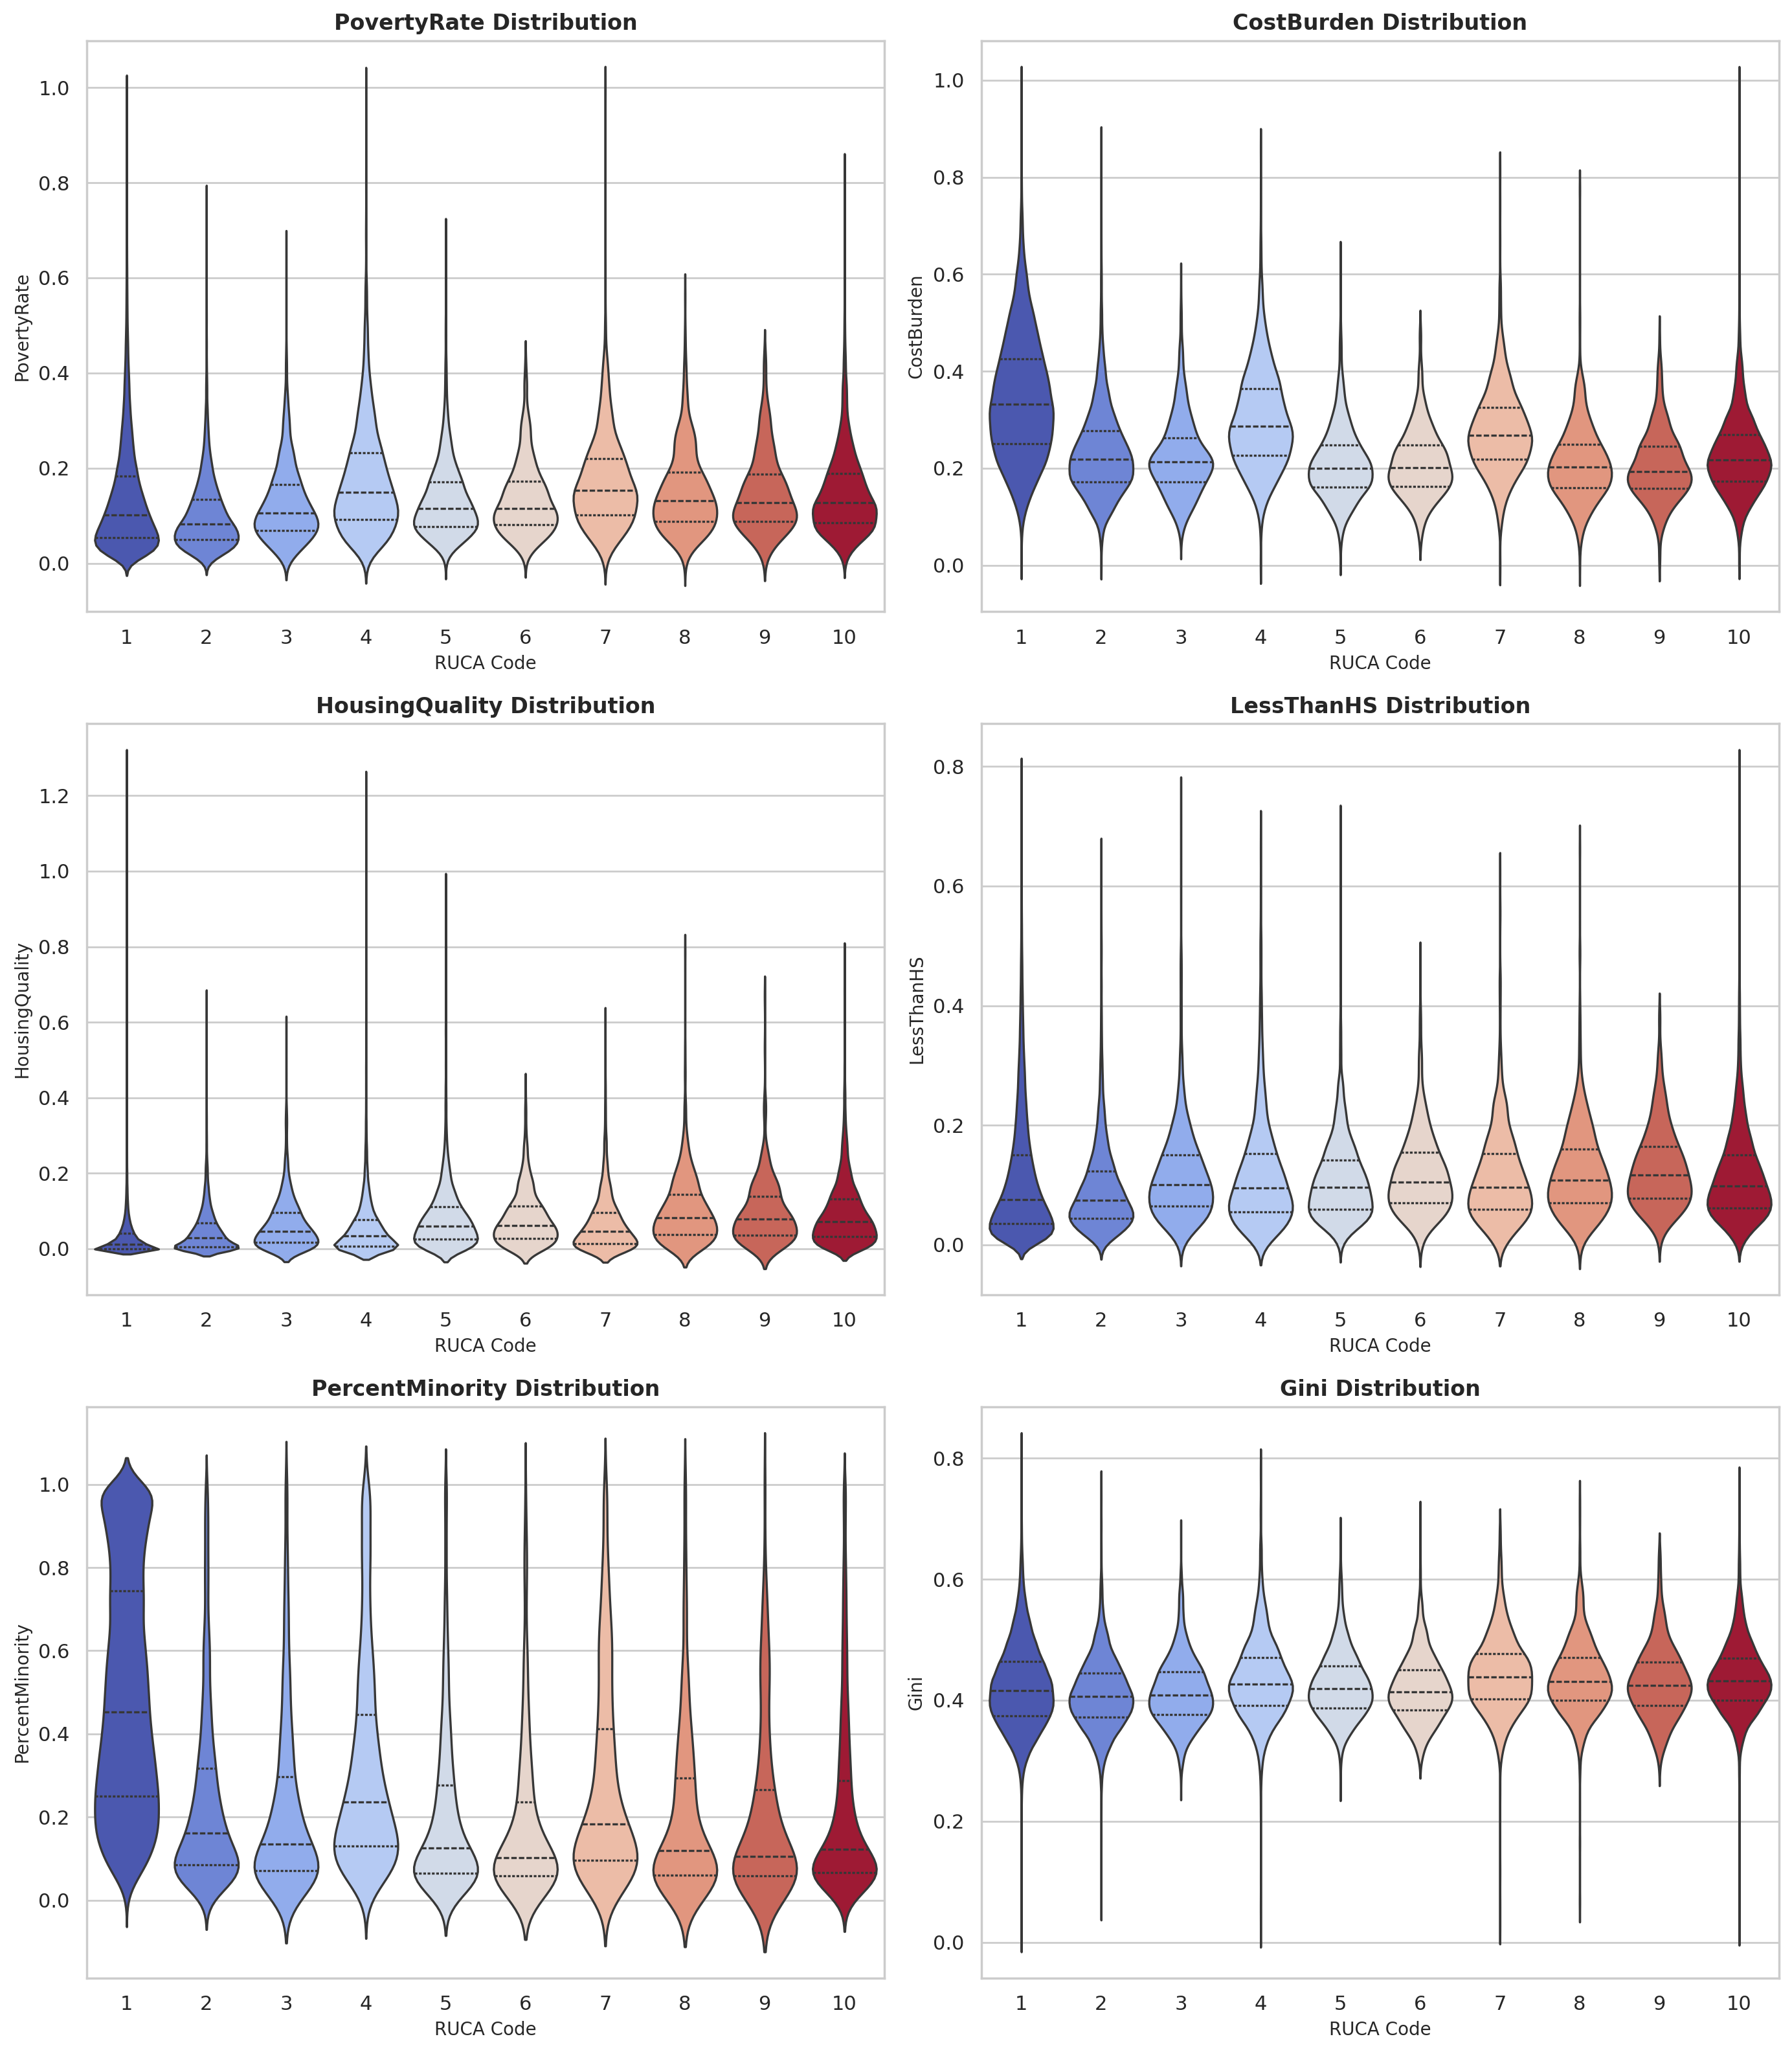
Inner lines show 25%, 50% (median), and 75% interquartile ranges. wider parts -> more tracts within value range, skinny parts -> fewer tracts within value range x axis = variable as a percentage of the population

3.2 Pearson Correlation Matrix
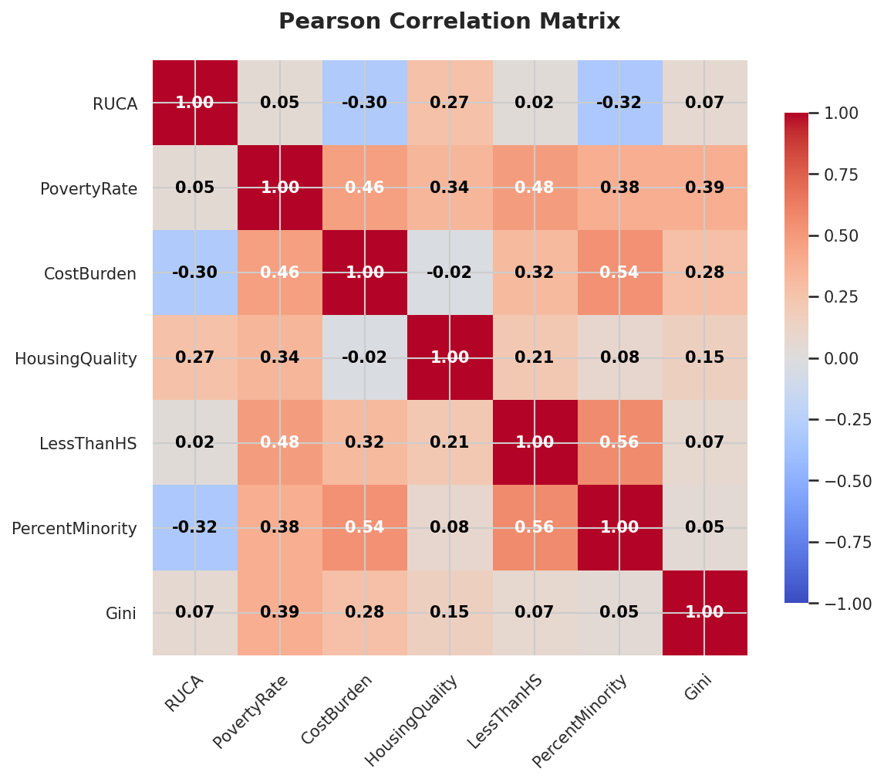
- The minority percentage and cost burden percentage of a census tract decreases as census tracts become more urban whereas poor housing quality go’s up.
- LessThanHS has decent postive correlations (0.3 - 0.5) with PovertyRate and PercentMinority

3.3 Variable Inflation Factor
 | feature | VIF
0 | PovertyRate | 4.343494
1 | CostBurden | 12.310752
2 | HousingQuality | 1.680772
3 | LessThanHS | 3.834566
4 | PercentMinority | 5.660608
5 | Gini | 8.526785
- VIF Interpretation
  - VIF ≈ 1: No correlation with other predictors
  - 1 < VIF ≤ 5: Mild to moderate correlation (usually fine)
  - VIF > 10: Strong multicollinearity -> take corrective steps
CostBurden and Percent Minority are over 5 but less than 6, so I don’t think they’ll cause significant multicolinearity issues.
At 8.5 the Gini coefficient is close to being problematic. Since it’s the main way the ACS measures income inequality, so unless it causes problems down the road I guess it’s fine ¯\(ツ)/¯

3.4 Multinomial Logistic Regression
Optimization terminated successfully.
Current function value: 0.931436
Iterations: 375
Function evaluations: 377
Gradient evaluations: 377
MNLogit Regression Results
==============================================================================
Dep. Variable: RUCA No. Observations: 81802
Model: MNLogit Df Residuals: 81739
Method: MLE Df Model: 54
Date: Sun, 07 Jun 2026 Pseudo R-squ.: 0.2071
Time: 12:41:17 Log-Likelihood: -76193.
converged: True LL-Null: -96090.
Covariance Type: nonrobust LLR p-value: 0.000
===================================================================================
RUCA=2 coef std err z P>|z| [0.025 0.975]
-----------------------------------------------------------------------------------
const 0.7639 0.091 8.381 0.000 0.585 0.943
PovertyRate -0.6955 0.220 -3.164 0.002 -1.126 -0.265
CostBurden -8.1085 0.171 -47.294 0.000 -8.445 -7.772
HousingQuality 6.3021 0.232 27.109 0.000 5.846 6.758
LessThanHS 9.4826 0.214 44.409 0.000 9.064 9.901
PercentMinority -5.0494 0.081 -62.492 0.000 -5.208 -4.891
Gini 0.6074 0.231 2.632 0.008 0.155 1.060
-----------------------------------------------------------------------------------
RUCA=3 coef std err z P>|z| [0.025 0.975]
-----------------------------------------------------------------------------------
const -1.3342 0.224 -5.956 0.000 -1.773 -0.895
PovertyRate 2.3709 0.472 5.024 0.000 1.446 3.296
CostBurden -10.0531 0.426 -23.574 0.000 -10.889 -9.217
HousingQuality 8.2449 0.433 19.042 0.000 7.396 9.094
LessThanHS 13.2341 0.437 30.263 0.000 12.377 14.091
PercentMinority -6.8611 0.193 -35.506 0.000 -7.240 -6.482
Gini 0.8517 0.563 1.512 0.130 -0.252 1.955
-----------------------------------------------------------------------------------
RUCA=4 coef std err z P>|z| [0.025 0.975]
-----------------------------------------------------------------------------------
const -1.6676 0.109 -15.243 0.000 -1.882 -1.453
PovertyRate 5.4197 0.177 30.537 0.000 5.072 5.768
CostBurden -3.9845 0.179 -22.309 0.000 -4.335 -3.634
HousingQuality 4.9088 0.239 20.550 0.000 4.441 5.377
LessThanHS 6.5278 0.224 29.102 0.000 6.088 6.967
PercentMinority -4.5614 0.089 -51.123 0.000 -4.736 -4.387
Gini 1.1015 0.266 4.145 0.000 0.581 1.622
-----------------------------------------------------------------------------------
RUCA=5 coef std err z P>|z| [0.025 0.975]
-----------------------------------------------------------------------------------
const -1.4349 0.164 -8.726 0.000 -1.757 -1.113
PovertyRate 4.2239 0.340 12.406 0.000 3.557 4.891
CostBurden -13.3378 0.333 -40.054 0.000 -13.991 -12.685
HousingQuality 9.7721 0.299 32.669 0.000 9.186 10.358
LessThanHS 11.3313 0.368 30.781 0.000 10.610 12.053
PercentMinority -6.9921 0.146 -47.879 0.000 -7.278 -6.706
Gini 4.1201 0.405 10.172 0.000 3.326 4.914
-----------------------------------------------------------------------------------
RUCA=6 coef std err z P>|z| [0.025 0.975]
-----------------------------------------------------------------------------------
const -1.9850 0.286 -6.939 0.000 -2.546 -1.424
PovertyRate 4.5077 0.558 8.073 0.000 3.413 5.602
CostBurden -12.5656 0.572 -21.986 0.000 -13.686 -11.445
HousingQuality 9.6827 0.489 19.793 0.000 8.724 10.642
LessThanHS 13.7956 0.554 24.892 0.000 12.709 14.882
PercentMinority -8.1782 0.256 -31.979 0.000 -8.679 -7.677
Gini 2.0686 0.710 2.913 0.004 0.677 3.460
-----------------------------------------------------------------------------------
RUCA=7 coef std err z P>|z| [0.025 0.975]
-----------------------------------------------------------------------------------
const -3.5833 0.184 -19.433 0.000 -3.945 -3.222
PovertyRate 5.5806 0.306 18.224 0.000 4.980 6.181
CostBurden -6.2996 0.317 -19.884 0.000 -6.921 -5.679
HousingQuality 6.8768 0.349 19.714 0.000 6.193 7.560
LessThanHS 7.8038 0.396 19.699 0.000 7.027 8.580
PercentMinority -5.5173 0.155 -35.610 0.000 -5.821 -5.214
Gini 4.3665 0.442 9.884 0.000 3.501 5.232
-----------------------------------------------------------------------------------
RUCA=8 coef std err z P>|z| [0.025 0.975]
-----------------------------------------------------------------------------------
const -3.8594 0.295 -13.087 0.000 -4.437 -3.281
PovertyRate 5.0861 0.562 9.053 0.000 3.985 6.187
CostBurden -14.1110 0.590 -23.910 0.000 -15.268 -12.954
HousingQuality 11.2457 0.431 26.065 0.000 10.400 12.091
LessThanHS 12.7613 0.604 21.123 0.000 11.577 13.945
PercentMinority -7.8149 0.251 -31.090 0.000 -8.308 -7.322
Gini 6.5252 0.706 9.248 0.000 5.142 7.908
-----------------------------------------------------------------------------------
RUCA=9 coef std err z P>|z| [0.025 0.975]
-----------------------------------------------------------------------------------
const -3.5497 0.392 -9.046 0.000 -4.319 -2.781
PovertyRate 5.2732 0.720 7.324 0.000 3.862 6.684
CostBurden -15.0318 0.801 -18.757 0.000 -16.603 -13.461
HousingQuality 10.4987 0.594 17.660 0.000 9.334 11.664
LessThanHS 14.1473 0.726 19.473 0.000 12.723 15.571
PercentMinority -7.8935 0.327 -24.111 0.000 -8.535 -7.252
Gini 4.6274 0.953 4.855 0.000 2.759 6.495
-----------------------------------------------------------------------------------
RUCA=10 coef std err z P>|z| [0.025 0.975]
-----------------------------------------------------------------------------------
const -1.7874 0.110 -16.211 0.000 -2.003 -1.571
PovertyRate 4.0689 0.222 18.322 0.000 3.634 4.504
CostBurden -11.1487 0.212 -52.605 0.000 -11.564 -10.733
HousingQuality 10.8718 0.214 50.712 0.000 10.452 11.292
LessThanHS 11.8330 0.249 47.512 0.000 11.345 12.321
PercentMinority -7.3449 0.100 -73.477 0.000 -7.541 -7.149
Gini 6.0515 0.269 22.535 0.000 5.525 6.578
===================================================================================
Pretty much all of the coefficients are statistically significant but considering the large number of observations and the very low amount of variation between values, I don’t think it really means much beyond being able to say they’re statistically significant.
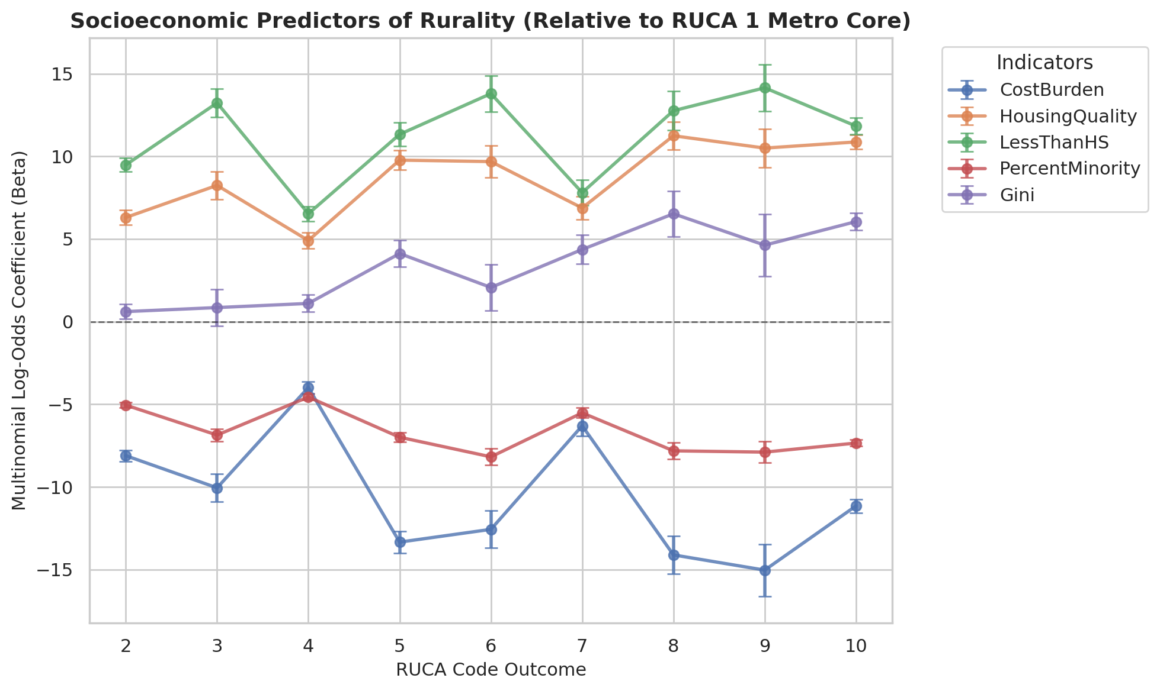
Positive multinomial log-odds coefficient: variable increase -> likelihood of class (RUCA code) increases.
Mean probability of correct classification: 59.81
Median probability of correct classification: 0.7298630414056722
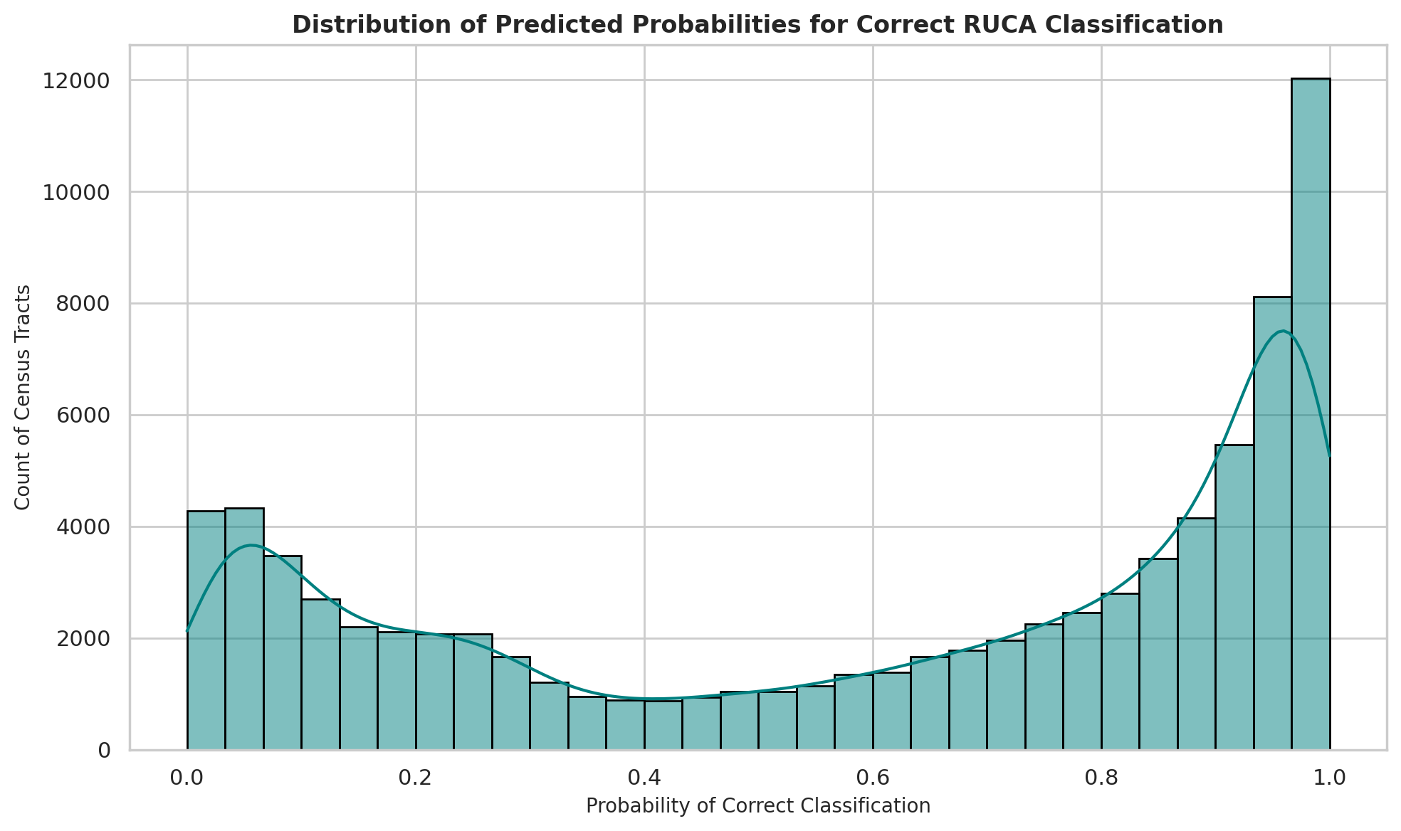

4. Spatial Analysis

